**Task Instructions**

In this task you complete two main sessions. **In the first session** you will see pairs of Japanese Hiragana symbols. Here is an example.

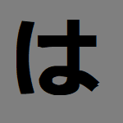

You will be asked to pick one of the two symbols.

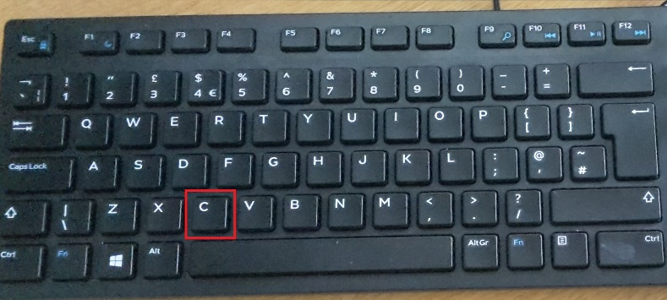Press **“C”** on the keyboard to select the symbol on the left.



Press **“M”** on the keyboard to select the symbol on the right.

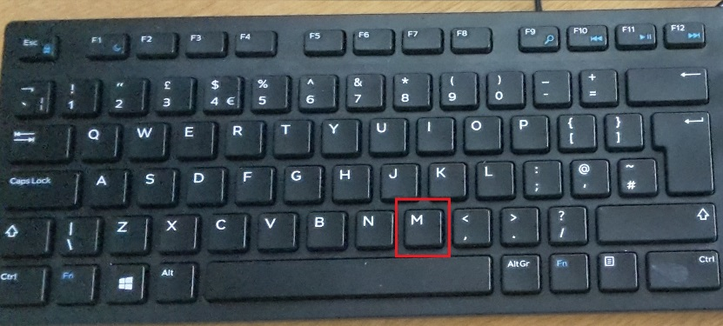

Your aim is to collect points throughout the task. After selecting one of the symbols you will see on the screen whether you scored new points.



In each pair, there is always one symbol which is more likely to give you points, but this is not always the case. One of the symbols is more **probable** to give you points.

**PLEASE NOTE:**

If you do not pick the symbol that gives you points you will instead lose your points.

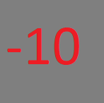

Your aim is to collect as many points as you can.

In the **second session,** you will see new combinations of the symbols. Your aim is still to collect as many points as you can.

**HOWEVER:**

This time you will not see any feedback on the screen to inform you whether you collect or lose your points.

You will complete the two sessions 3 times. Each time you will see different symbols.

Thank you for taking part!